

19P0012 AITZAZ TAHIR CH

DATA BASE LAB 10 SIR MUHAMMAD USMAN



**Create a database name person and create the tables above.**

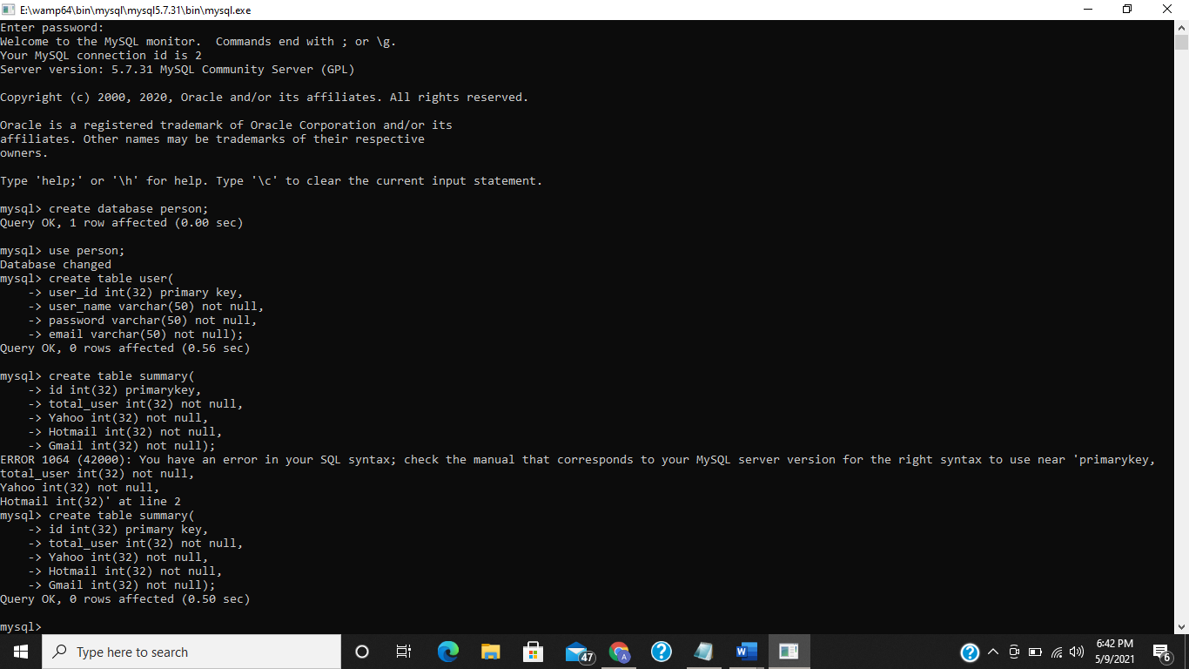

**1. Write a procedure that take id, total_user, Yahoo, Hotmail, Gmail values as an input and insert the data into the table summary.**

create procedure insert_summary (in var1 int,in var2 int,in var3 int,in var4 int,in var5 int)

-> begin

-> insert into summary (id,total_user,Yahoo,Hotmail,Gmail) values (var1,var2,var3,var4,var5);

-> end$$

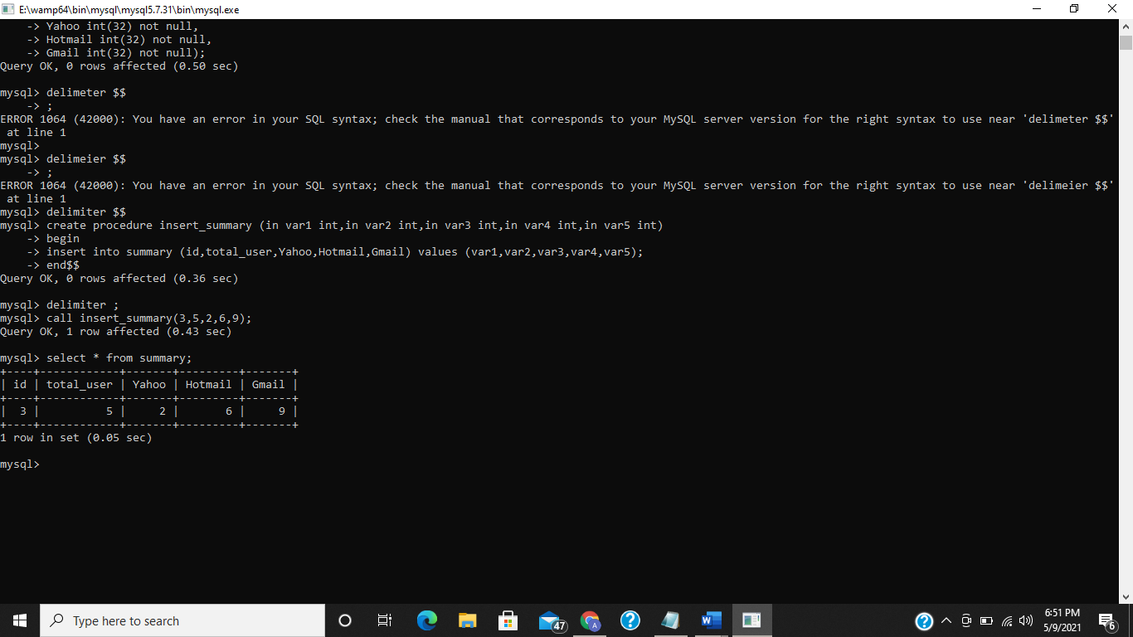

**2. Write a procedure that take user_id, username, password, email values as an input**

**and insert the data into the table Users.**

create procedure insert_users(in user_id int,in username varchar(50),in password varchar(50),in email varchar(50))

-> begin

-> insert into user(user_id,user_name,password,email) values(user_id,username,password,email);

-> end $$

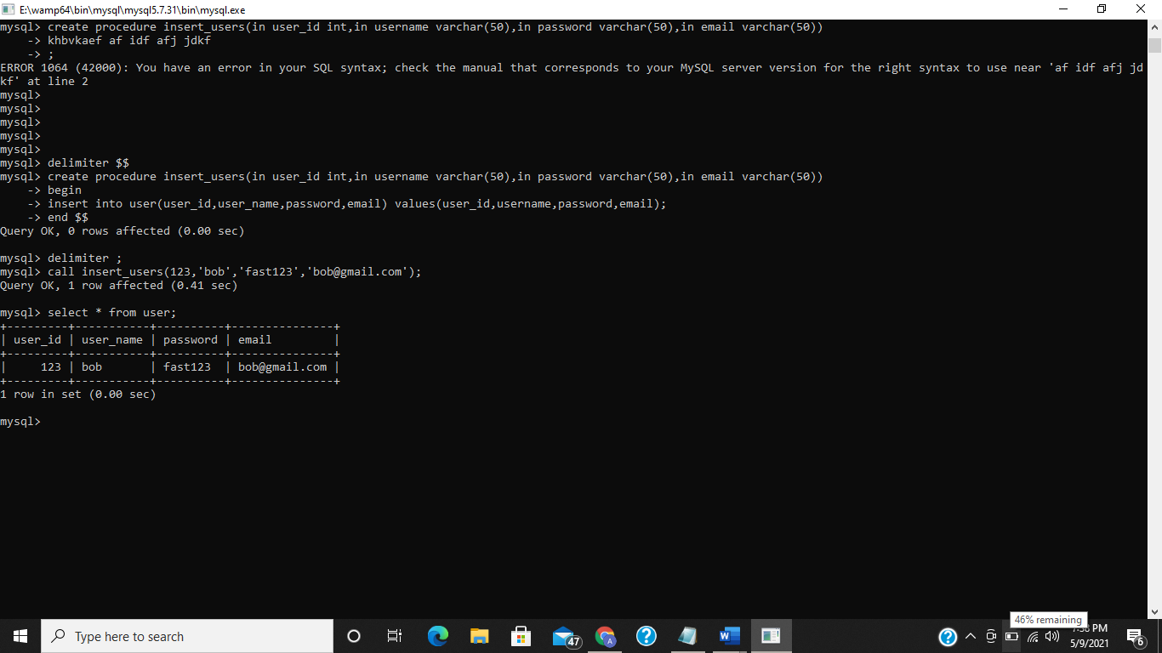

**3. Write a procedure that output the average value of yahoo.**

create procedure avg_yahoo(out avg decimal)

-> begin

-> select avg(Yahoo) into avg from summary;

-> end$$

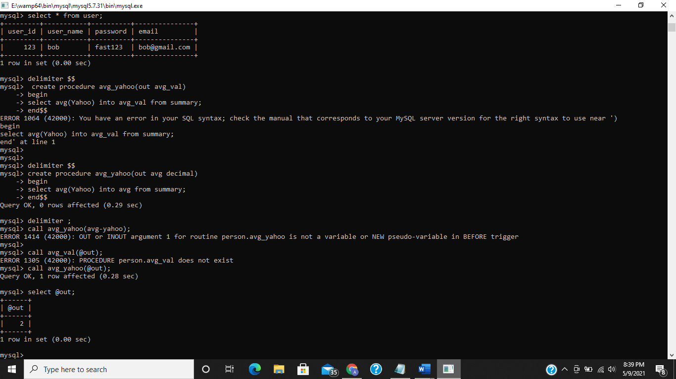

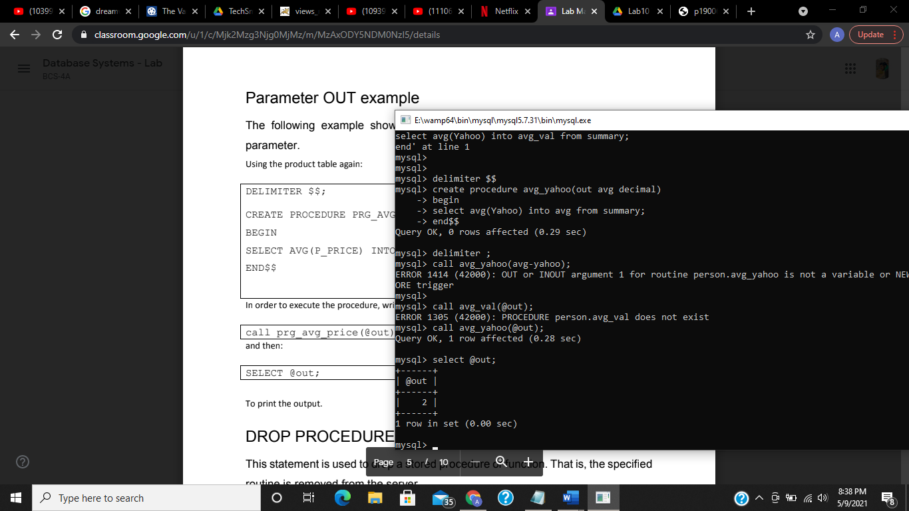

**4. Write a procedure that output the min value of Gmail.**

create procedure min_gmail(out min int)

-> begin

-> select min(Gmail) into min from summary;

-> end$$



**5. Write a procedure that output the max value of Hotmail.**

create procedure max_hotmail(out max int)

-> begin

-> select max(Hotmail) into max from summary;

-> end$$



**6. Write a procedure that increment the total user by 1 when yahoo value is less than equal to Hotmail.**

create procedure inc()

-> begin

-> update summary

-> set total_user = total_user+1

-> where Yahoo <= Hotmail;

-> end $$



**7. Create trigger(s) to update the records in the summary table. The summary table**

**will contain only one record and will be updated each time a new entry is made to**

**the users table, or a user is deleted from the users table. You need to create the**

**following two triggers.**

**I. Whenever a new entry is made to the user’s table then total_user attribute in**

**the summary table must be incremented by 1.**

create trigger inc after insert on person.user for each row

-> begin

-> update summary set total_user=total_user+1;

-> end $$

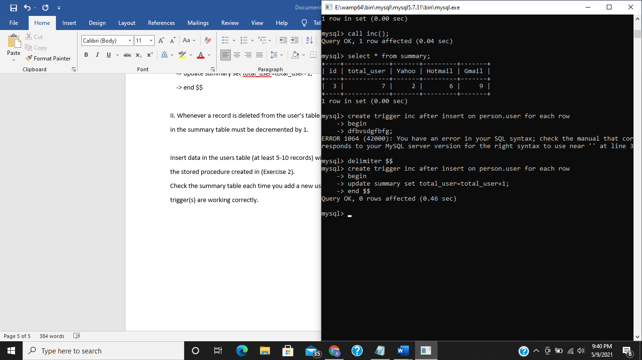

**II. Whenever a record is deleted from the user’s table then total_user attribute**

**in the summary table must be decremented by 1.**

create trigger decr after

-> delete on person.user for each row

-> begin

-> update summary set total_user = total_user-1;

-> end $$

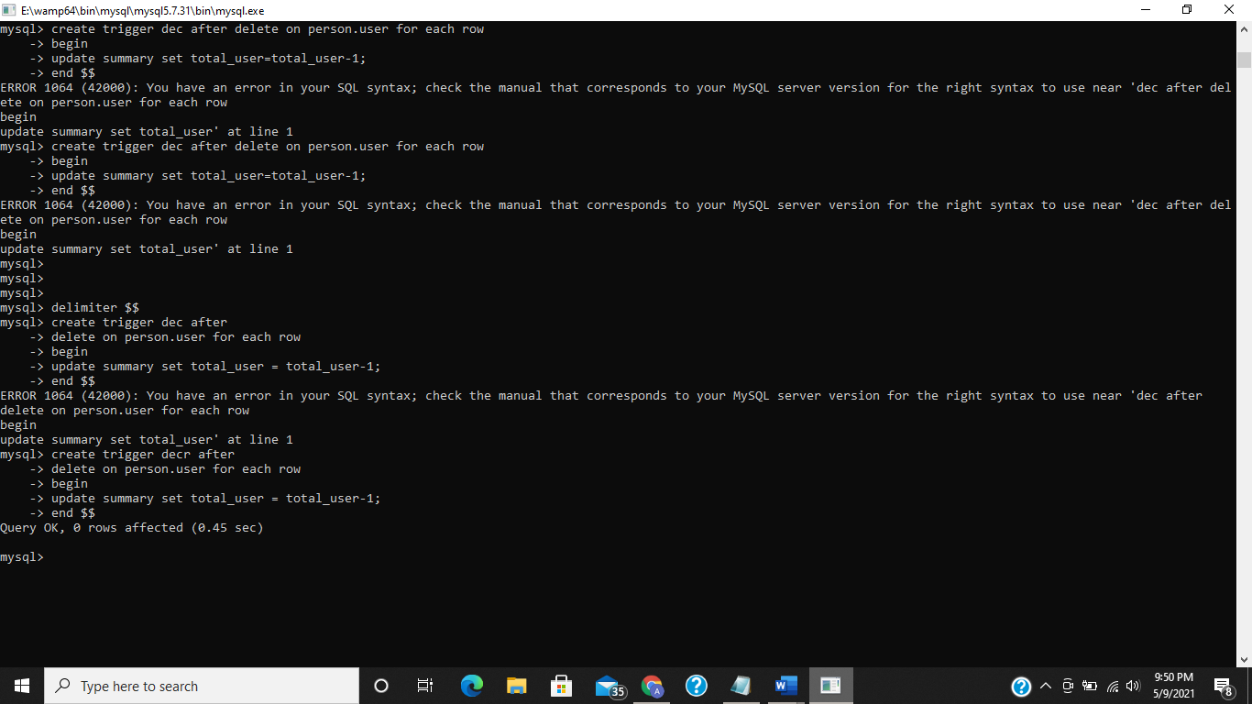

**Insert data in the users table (at least 5-10 records) with different email addresses using**

**the stored procedure created in (Exercise 2).**

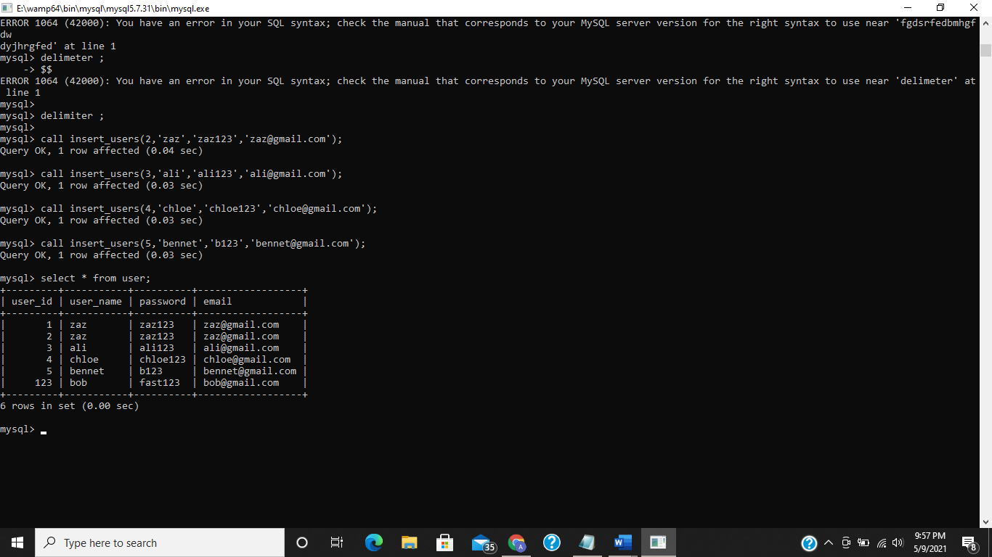

**Check the summary table each time you add a new user or delete a user to check if the trigger(s) are working correctly.**

